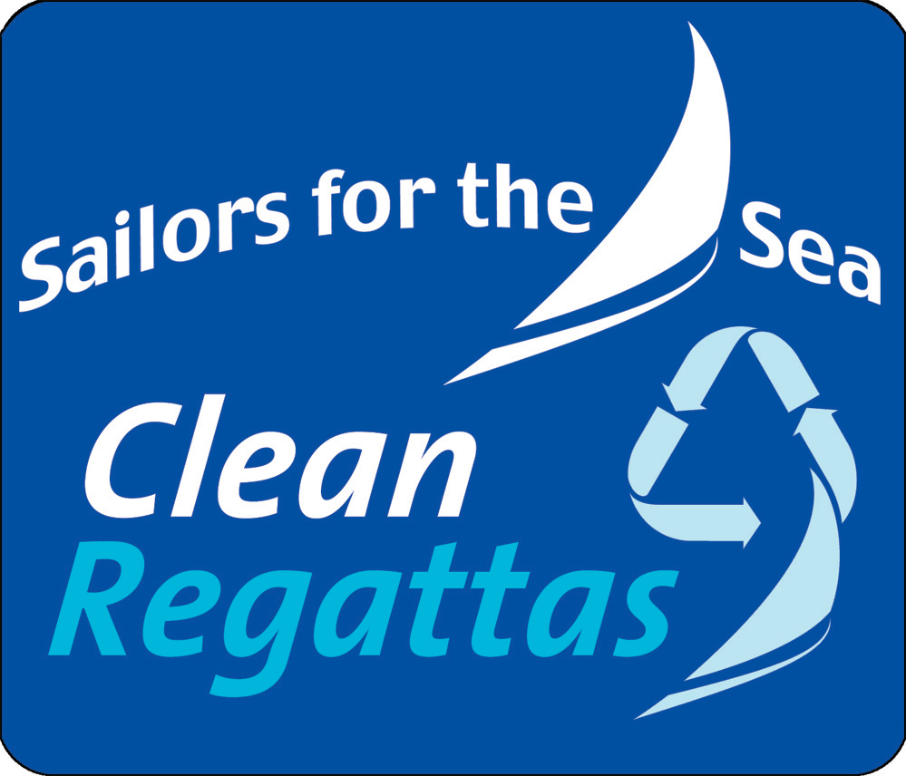
Sailors for the Sea Clean Regatta Criteria:

1. Green Team
Form a team of volunteers who can manage your Clean Regattas efforts.

2. Water Bottle Reduction
Reduce or eliminate the use of disposable plastic bottles.

3. Trash Free Regatta
Keep your regatta site trash free.

4. Recycling
Provide and promote recycling services during your regatta.

5. Compost
Provide composting at your regatta site for food scraps and/or compostable food service products.

6. Non-Toxic Cleaning Products
Use only non-toxic cleaning products during your event.

7. Gray Water Reduction
Reduce gray water runoff from your event.

8. No Discharge
Prevent the discharge of treated and untreated sewage in nearshore environments.

9. Oil Spill Prevention
Prevent oil spills from happening during your event by using oil spill kits and creating an Oil Spill Response Plan.

10. Paper
Reduce paper usage by switching to paperless communications. Use recycled paper for required printing

11. Biodegradable Products
Use biodegradable, compostable or durable products for your events.

12. Bottom Paint
Use copper-free bottom paints on all event vessels.

13. Bottom Cleaning
Ensure that bottom cleaning takes place in approved areas and at approved times.

14. Maintenance
Ensure toxic emissions from maintenance practices are properly contained.

15. Carbon Footprint
Reduce your regatta's carbon footprint.

16. Recycled Trophies
Use recycled or practical items as regatta awards.

17. Stormwater Pollution Prevention
Prevent stormwater pollution from your event.

18. Alternative Fuels
Use alternative fuels, such as biodiesel, in regatta boats and generators.

